Activity | Data Type
Number of beatings from Wife | Descrete
Results of rolling a dice | Descrete, Ordinal
Weight of a person | Continous, Ratio
Weight of Gold | Continous, Ratio
Distance between two places | Continous, Ratio
Length of a leaf | Continous, Ratio
Dog's weight | Continous, Ratio
Blue Color | Nominal
Number of kids | Descrete, Ordinal
Number of tickets in Indian railways | Descrete, Ordinal
Number of times married | Descrete, Ordinal
Gender (Male or Female) | Nominal
Q1) Identify the Data type for the Following:

Q2) Identify the Data types, which were among the following
Nominal, Ordinal, Interval, Ratio.
Data | Data Type
Gender | Nominal
High School Class Ranking | Ordinal
Celsius Temperature | Interval
Weight | Ratio
Hair Color | Nominal
Socioeconomic Status | Ordinal
Fahrenheit Temperature | Interval
Height | Ratio
Type of living accommodation | Ordinal
Level of Agreement | Ordinal
IQ(Intelligence Scale) | Ratio
Sales Figures | Interval
Blood Group | Nominal
Time Of Day | Ratio
Time on a Clock with Hands | Ratio
Number of Children | Ordinal
Religious Preference | Nominal
Barometer Pressure | Ordinal
SAT Scores | Ordinal
Years of Education | Interval
Q3) Three Coins are tossed, find the probability that two heads and one tail are obtained?
Answer : 3/8
Q4) Two Dice are rolled, find the probability that sum is
- Equal to 1
Answer : Zero
- Less than or equal to 4
Answer : 6/36 or 1/6
- Sum is divisible by 2 and 3
Answer : 6/36 or 1/6
When two dices are rolled, sample space is given as:
(1,1) (1,2) (1,3) (1,4) (1,5) (1,6)
(2,1) (2,2) (2,3) (2,4) (2,5) (2,6)
(3,1) (3,2) (3,3) (3,4) (3,5) (3,6)
(4,1) (4,2) (4,3) (4,4) (4,5) (4,6)
(5,1) (5,2) (5,3) (5,4) (5,5) (5,6)
(6,1) (6,2) (6,3) (6,4) (6,5) (6,6)

Q5) A bag contains 2 red, 3 green and 2 blue balls. Two balls are drawn at random. What is the probability that none of the balls drawn is blue?

Answer : 7C2 / 5C2 = 10/21
or
There are 7 balls originally with 2 of them blue so the probability of the first ball not being blue is 5/7. This leaves 6 balls with 2 blue. The probability of the second ball not being blue assuming that the first wasn’t is 4/6. The probability that neither ball drawn was blue is (5/7)*(4/6) = 20/42=10/21
Q6) Calculate the Expected number of candies for a randomly selected child
Below are the probabilities of count of candies for children (ignoring the nature of the child-Generalized view)
CHILD | Candies count | Probability
A | 1 | 0.015
B | 4 | 0.20
C | 3 | 0.65
D | 5 | 0.005
E | 6 | 0.01
F | 2 | 0.120
Child A – probability of having 1 candy = 0.015.
Child B – probability of having 4 candies = 0.20
Answer : (1*0.015)+(4*0.20)+(3*0.65)+(5*0.005)+(6*0.01)+(2*0.120) = 3.09
Q7) Calculate Mean, Median, Mode, Variance, Standard Deviation, Range & comment about the values / draw inferences, for the given dataset
- For Points,Score,Weigh>
Find Mean, Median, Mode, Variance, Standard Deviation, and Range and also Comment about the values/ Draw some inferences.
Answer : Point Score Weigh
Mean 3.596 3.217 17.849
Median 3.695 3.325 17.71
Mode 3.07, 3.92 3.44 17.02,18.90
Variance 0.286 0.957 3.193
Std 0.535 0.978 1.787
Range 2.17 3.9109 8.3999
Inferences:
For Points dataset:
1) The data is centered around Median
2) There are no outliers
3) Data is Right skewed
For Score dataset:
1) The data is concentrated around Median
2) There are 3 outliers
: 5.250, 5.345and 5.424
3) Data is Left skewed
For Weigh dataset:
1) The data is concentrated around Median
2) There is only 1 outlier i.e 22.90
3) Data is Left skewed
Use Q7.csv file
Q8) Calculate Expected Value for the problem below
- The weights (X) of patients at a clinic (in pounds), are
108, 110, 123, 134, 135, 145, 167, 187, 199
Assume one of the patients is chosen at random. What is the Expected Value of the Weight of that patient?
Answer : EV for descrete randon variable when list is given is equivalent to mean i.e 145.333

Q9) Calculate Skewness, Kurtosis & draw inferences on the following data
Cars speed and distance
Use Q9_a.csv
Answer : Skewness
speed -0.117510
dist 0.806895
Inferences: speed data is fairly symetrical while dist data is moderately skewed
(Note:
If the skewness is between
-0.5 and 0.5, the data are fairly symmetrical
If the skewness is between -1 and – 0.5 or between 0.5 and 1, the data are moderately skewed
If the skewness is less than
-1 or greater than 1, the data are highly skewed)

Kurtosis
speed -0.508994
dist 0.405053

Inferences:
speed distribution has light tails (platykurtic distribution)
dist distribution has heavier tails (leptokurtic distribution)
(Note:
If the kurtosis is close to 0, then a normal distribution is often assumed, These are called mesokurtic distributions
If the kurtosis is less than zero, then the distribution is light tails and is called a platykurtic distribution.
If the kurtosis is greater than zero, then the distribution has heavier tails and is called a leptokurtic distribution)

SP and Weight(WT)
Use Q9_b.csv
Answer : Skewness
SP 1.611450
WT -0.614753
Inferences: SP data is highly skewed(Positive), WT data is moderately skewed(Negative)
Kurtosis
SP 2.977329
WT 0.950291
Inferences: SP & WT both are having heavier tail(Leptokurtic distribution)
Q10) Draw inferences about the following boxplot & histogram
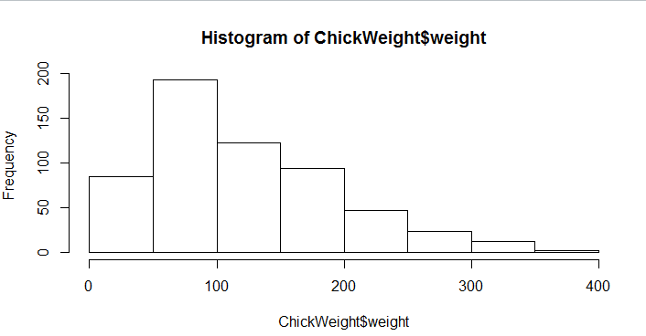
Inference : Data is right skewed (positively skewed)
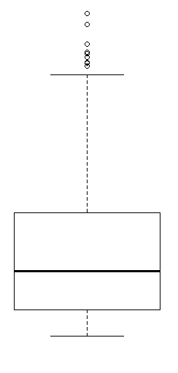
Inference : Having outliers in the data.
Q11) Suppose we want to estimate the average weight of an adult male in Mexico. We draw a random sample of 2,000 men from a population of 3,000,000 men and weigh them. We find that the average person in our sample weighs 200 pounds, and the standard deviation of the sample is 30 pounds. Calculate 94%,98%,96% confidence interval?
Answer : CI @94% - (198.738325292158, 201.261674707842)
CI @96% - (198.62230334813333, 201.37769665186667)
CI @98% - (198.43943840429978, 201.56056159570022)
Q12) Below are the scores obtained by a student in tests
34,36,36,38,38,39,39,40,40,41,41,41,41,42,42,45,49,56
- Find mean, median, variance, standard deviation.
Answer : Mean =41, Median =40.5, Variance =25.529, SD=5.052664

- What can we say about the student marks?
Inferences : 1. Student marks are not normally distributed.
2. Two marks are outliers i.e 49 & 56.
Q13) What is the nature of skewness when mean, median of data are equal?
Answer : Distribution is symmetric when mean= median
Q14) What is the nature of skewness when mean > median ?
Answer : Distribution is positively skewed.
Q15) What is the nature of skewness when median > mean?
Answer : Distribution is negatively skewed.
Q16) What does positive kurtosis value indicates for a data ?
Answer : Positive values of kurtosis indicate that a distribution is peaked and possesses thick tails.
Q17) What does negative kurtosis value indicates for a data?
Answer : Negative values of kurtosis indicate that a distribution is less peaked and possesses thinner tails.
Q18) Answer the below questions using the below boxplot visualization.
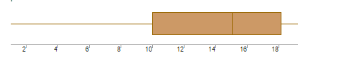
What can we say about the distribution of the data?
Answer : Data is not distributed normally.
What is nature of skewness of the data?
Answer : Distribution is skewed left.
What will be the IQR of the data (approximately)?
Answer :Iif Q1= 10, Q3= 18 (approximately) then
IQR = Q3-Q1 i.e 18-10= 8 (approximatlely)
Q19) Comment on the below Boxplot visualizations?
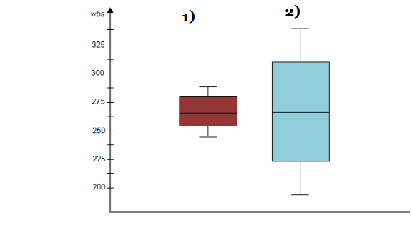
Draw an Inference from the distribution of data for Boxplot 1 with respect Boxplot 2.
Inference :
1. None of the boxplot is having any outliers.
2. Box & whisker of Boxplot 1 shows range of data is smaller and all the data points are near median, whereas Boxplot 2 have wider distribution(more scattered data ).
3. LQ of Boxplot 1 is higher than LQ of Boxplot 2, and UQ of Boxplot 1 is lower than UQ of Boxplot 2
Q 20) Calculate probability from the given dataset for the below cases

Data _set: Cars.csv
Calculate the probability of MPG of Cars for the below cases.
MPG <- Cars$MPG
  - P(MPG>38)
Answer : 0.347583

  - P(MPG<40)
Answer : 0.270637

  - P (20<MPG<50)
Answer : 0.89888

Q 21) Check whether the data follows normal distribution
- Check whether the MPG of Cars follows Normal Distribution
Dataset: Cars.csv
Answer : ‘MPG’ data follows normal distribution, since mean and median are almost equal.
- Check Whether the Adipose Tissue (AT) and Waist Circumference(Waist) from wc-at data set follows Normal Distribution
Dataset: wc-at.csv
Answer : Waist data is normally distributed approximately, since mean & median are almost equal. AT (Adipose Tissue) is slightly right skewed

Q 22) Calculate the Z scores of 90% confidence interval,94% confidence interval, 60% confidence interval
Answer : Z Scores
90% = 1.645
94% = 1.881
60% = 0.841
Q 23) Calculate the t scores of 95% confidence interval, 96% confidence interval, 99% confidence interval for sample size of 25
Answer : t Scores
95% = 1.9739
96% = 2.1715
99% = 2.7969

Q 24) A Government company claims that an average light bulb lasts 270 days. A researcher randomly selects 18 bulbs for testing. The sampled bulbs last an average of 260 days, with a standard deviation of 90 days. If the CEO's claim were true, what is the probability that 18 randomly selected bulbs would have an average life of no more than 260 days
Answer : .3216

